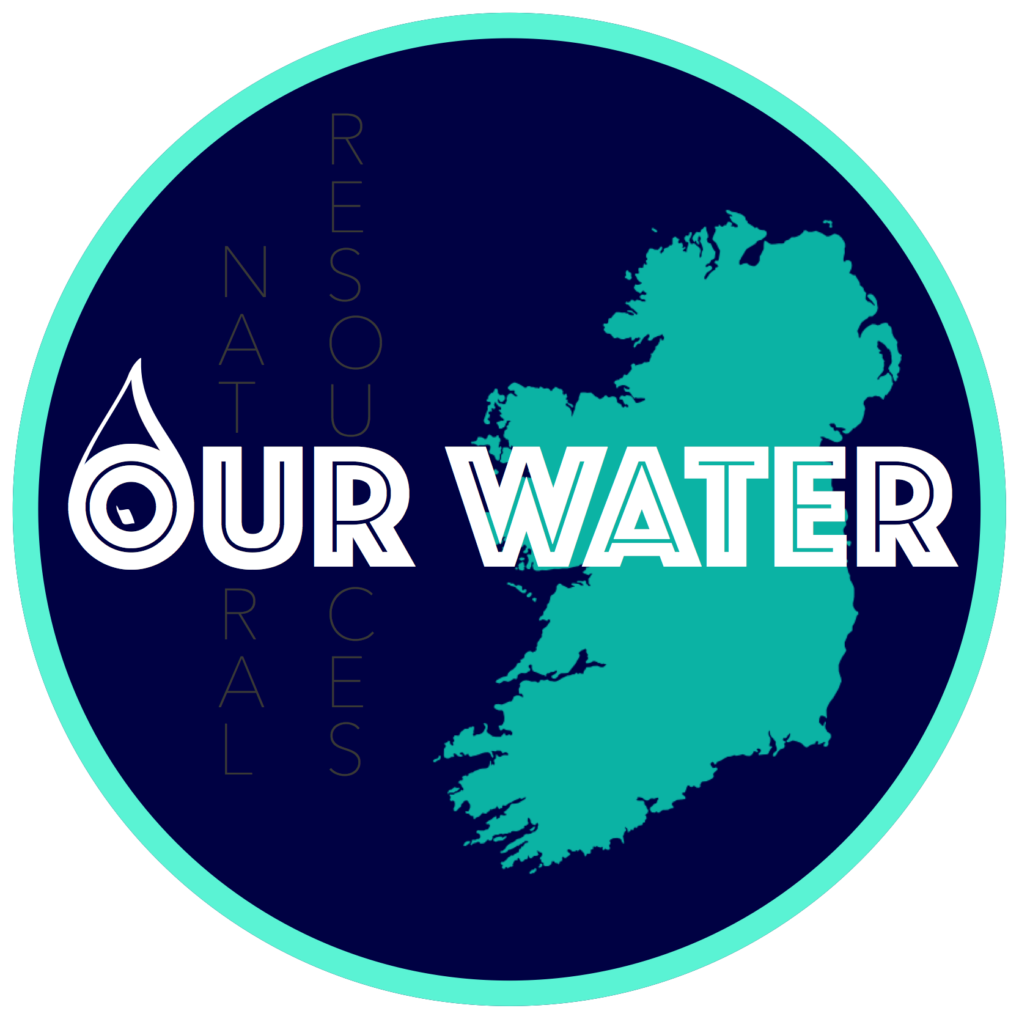
Campaign to save Ireland’s 9.4 E
xemption.

Last Walk On Water

Please help us by pledging what you can afford towards a fund to cover costs towards legal advice. An appointment has been arranged for Our Water delegation to meet with Senior Counsel. The total cost will be €2500.

It is unfortunate that we are left with no other option but we can not let this very important issue go without exploring all possibilities. We are seeking advice about the way the Irish Government’s has interpreted and handled Ireland’s Established Practice in relation to domestic water charging.

In particular we are interested in Section 9.4 of the Water Framework Directive 2000 and the importance this section has for Ireland’s ability to retain the principle of ‘Establish Practice’ of funding domestic water through general taxation. We are also questioning whether the Irish Government failed to directly invoke this section in it’s 2018 River Basin Management Plan which was finalised and submitted to Brussels for approval in April.

We see our case as a last ditch defence against our Government’s sly moves of trying to ignore and sideline Section 9.4 and Ireland’s long historic established practice. The government and EU Commission see Section 9.4 of the Water Framework Directive as an impediment to their future plans and would dearly love to see it go away. We must not let this happen.

We see Section 9.4 of the Water Framework Directive 2000 as a defence of democracy at home and the EU. It supports the widespread opposition to water charges in Ireland and was the result of many campaigns against water charges in the 1970s, 1990s and 2013. These campaigns overturned the Irish Government's many attempts at introducing domestic water charges.

We must insist that Section 9.4 and our established practice is clearly defined in Irish and European law so that this barrier to full cost recovery will not be let go by default. It is imperative that the Government is made to clearly invoke Section 9.4 and that our Established Practice is enshrined in any future plan. If you are in any doubt about the Government’s intention - read paragraph 9 of the recent RBMP, link below.

If we can get this hard fought Irish exemption squarely and unequivocally on the table then we will put a spanner in the works. If we succeed we might be able to take power away from the Government and political parties and bring it back to where it belongs, the people. We fought too long and hard to let it slip away now.

We must get a definitive answers to whether Ireland still has the right to invoke Section 9.4 of the Water Framework Directive and whether the Irish Government failed to invoke it in it’s 2018 River Basin Management Plan? Has our Establish Practice elapsed and no longer valid as Brussels maintains? Or as the Expert Commission report on Domestic Water Services 2016, para 5.9.4 page 42 stated;

″While considerable weight must be given to the opinion of the European Commission, the definitive interpretation of European law is a matter for the Court of Justice of the European Union.″

Second RBMP; http://www.housing.gov.ie/sites/default/files/publications/files/rbmp_full_reportweb.pdf

For further information email ourwater94@gmail.com or contact any of the following signatories;

Michael Mooney, Letterkenny
James Quigley, Buncrana
Enda Craig, Moville
Angela McGovern, Ballyshannon
Anthony Cassidy, Athlone
Mark McAuley, Dublin
Jim O Sullivan, Cork
Steve Sinclair, Dublin
Seamus Ward, Drogheda
Brendan Kelly, Galway

