-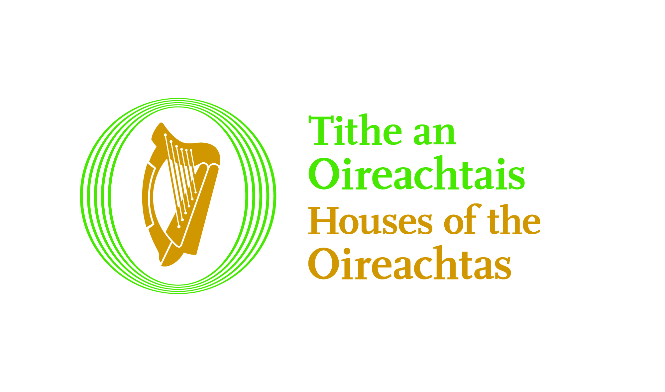 | Rúnaíoacht na gCoistí  Tithe an Oireachtais  Teach Laighean  Baile Átha Cliath 2  Guthán: (01) 618 3481 | Committees Secretariat  Houses of the Oireachtas  Leinster House  Dublin 2  Tel: (01) 618 3481
Our Ref: R1416

18 September 2017

Dear Mr Quigley,

I refer to your request under the Freedom of Information Act 2014, which was received by the Houses of the Oireachtas Service on 8 September 2017, and in which you requested access to:

“all submissions, records and minutes of all Private Sessions and any information other than was made public through the Oireachtas site, relating to the Joint Oireachtas Committee on the Future Funding of Domestic Water Services, that took place between 13th December 2016 and 11th April 2017.”

I note your clarification that “We believe there were 21 meetings in total and all had private sessions and submissions that were not made public. We believe we have a right to know what took place in our name, who voted for what and what is the actual truth of events during those proceedings.
We are particularly interested in the 15th February 2017 sessions and all the 10 'Private Sessions' between 28th February 2017 and 11th April 2017.”

I have reviewed your request, and have considered all of the records to which you refer in the context of the specific provisions in the Freedom of Information Act 2014. Arising from that review, I do not believe that any of the records to which you have requested access falls to be released under the Act, as the Freedom of Information Act 2014 does not apply to those records. I have set out the reasons for this finding in the following paragraphs.

Although neither of the Houses of the Oireachtas nor the Joint Committee on the Future Funding of Domestic Water Services (which was a Special Committee) is an FOI body, I have treated your request as being one made to the Houses of the Oireachtas Service in respect of records to which you have referred.

Section 42 (k) of the Freedom of Information Act 2014 states the Act does not apply to ‘a record relating to any of the private papers (within the meaning of Article 15.10 of the Constitution) of a member of either House of the Oireachtas or an official document of either or both of such Houses that is required by the rules or standing orders of either or both of such Houses to be treated as confidential.’

Section 127(1) of the Houses of the Oireachtas (Inquiries, Privileges and Procedures) Act 2013, as applied by section 26(2)(f) of the Interpretation Act 2005, provides that ‘Without prejudice to the exemption for official documents and private papers, the [Freedom of Information Act 2014] shall not apply to a record relating to a Part 2 inquiry or other committee business….’ ‘Other committee business’ is defined in s. 2(1) of the 2013 Act as committee business, such as the business of Special Committee.

The exemption in s. 127(1) of the 2013 Act (but not the exemption in s. 42(k) of the 2014 Act) is subject to qualification where ‘(a) the record was created before the inquiry or other committee business, as the case may be, commenced, or (b) the record relates to the expenses of the committee or other matters concerning the general administration of the committee.’

In my opinion, all of the records which are within the terms of your request fall within the exemption created by s. 42(k) of the 2014 Act, and many of them also fall within the exemption created by s. 127(1) of the 2013 Act, and for both reasons, I must refuse to grant access to those records.

I have enclosed extracts of the relevant legislation and Standing Orders of Dáil Éireann for your information as follows.

- Freedom of Information Act 2014 (Section 42);
- Houses of the Oireachtas (Inquiries, Privileges and Procedures) Act 2013 (Section 127);
- Dáil Éireann Standing Orders Relative to Public Business (Standing Order 134 and Schedule 1).

The complete texts of these documents are available on the internet.

You may seek an internal review of this decision. To do so, you should write to:
FOI and Records Management Unit,
Library & Research Service,
Houses of the Oireachtas Service,
Kildare Street,
Dublin 2,
referring to this decision. You should make your appeal within 4 weeks from the date of this notification, where a day is defined as a working day excluding the weekend and public holidays. However, the making of a late appeal may be permitted in appropriate circumstances. The appeal will involve a complete reconsideration of the matter by a more senior member of the staff of the Service. Details regarding the fees for making an appeal are set-out below.

Should you have any further queries regarding these records, you should contact Verona Ní Bhroinn, Press and PRO, on 01 6183881 or by e-mail at verona.nibhroinn@oireachtas.ie.

Yours sincerely,

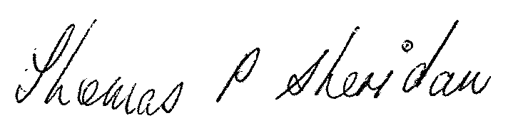
________________________________
Thomas P. Sheridan
Clerk to the (former) Joint Committee on the Future Funding of Domestic Water Services

Fees for internal review

Under the Freedom of Information Act 2014, a standard fee of €30 must accompany an application for internal review under chapters 1 & 2 of the Act. A reduced fee of €10 applies if you are covered by a medical card, in which case you should supply details of the medical card registration number and your consent to verification of these details. The fee can be paid by cheque or postal order payable to the “Houses of the Oireachtas Service”. The following internal review applications are exempt from fees:
- an application in relation to a decision concerning records containing only personal information related to the applicant.
- an application in relation a decision under section 9 (right of amendment of records relating to personal information).
- an application in relation to a decision under section 10 (right of person to information regarding acts of public bodies affecting the person).
- an application in relation to a decision to charge a fee or deposit, or a fee or deposit of a particular amount.

If you have any queries in relation to fees for internal review, please do not hesitate to contact the FOI co-ordinator, Ms Jennifer McGrath at 01 618 4712.

